Adverse/side Effects
-dizziness, fatigue, hypotension, weight gain, hyperglycemia, diarrhea, bradycardia, nausea, cough, headache, rhinitis, vomiting, hypercholesterolemia, insomnia, thrombocytopenia, edema, hepatic injury, depression, deterioration of renal function, allergic reaction….
Recommended dosages
Immediate Release
=3.125 mg PO q12hr for 2 weeks, then increased every 2 weeks as tolerated to 6.25 mg, 12.5 mg, or 25 mg PO twice daily.
Extended Release
=10 mg/day PO; maintained for 1-2 weeks if tolerated; may be increased to 20 mg/day, 40 mg/day, or 80 mg/day PO if necessary.

Indications
- Hypertension
- Congestive heart failure
- Myocardial infarction (Left Ventricular Dysfunction)
- Angina pectoris

CARVEDILOL
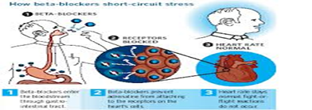
Contraindications
- Hypersensitivity reaction like stevens-johnson syndrome
- Anaphylactic shock and angioedema.
- Bronchial asthma.
- Chronic obstructive pulmonary disease (COPD).
- Second or third-degree atrioventricular block
- Severe hepatic impairment.
